CSE 581

**Lab 1: Database Account Setup**

**Figure 1: the account set up and access to NorthWind database.**

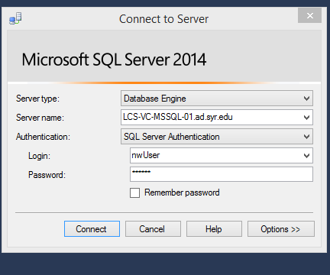

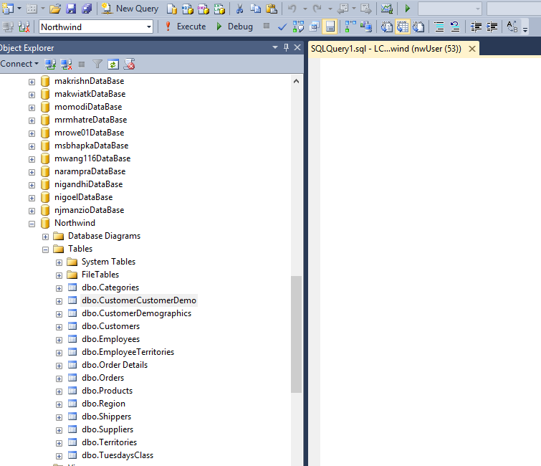

**Figure 1**

**Figure 2: the account set up and access to my own database.**

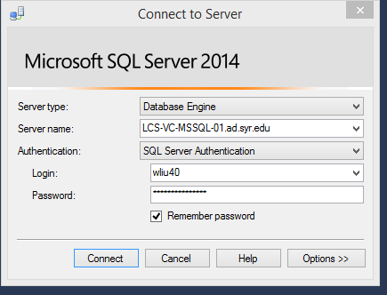

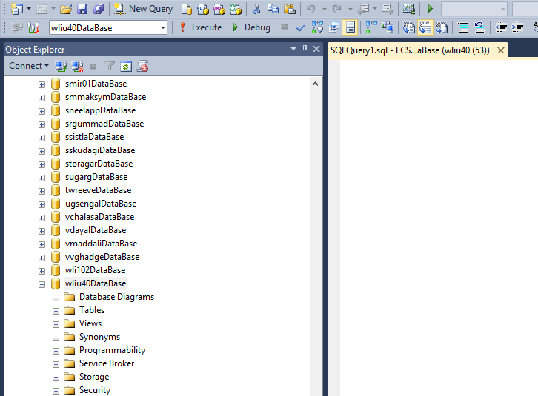

**Figure 2**